**BMI Calculator**

**Introduction: I am Lakshmi Sirisha C having 10years experience in IT field.**

**I worked on Java most of my carrier till now. But also worked on many technologies like front java script,html,jsp and backend oracle. I also worked on ContentManagement.**

**I developed Standalone BMI Calculator in javascript using NodeJS. This program take JSON file as input and outputs the BMI of each person along with the health risk. This program also outputs the total number of persons in the file who are overweight.**

**Prerequistes:**

1. **Installation of NodeJS v.8.9.4**
2. **Installation of prompt-sync in node js**

**Running the application:**

1. **Open the NodeJS command prompt**

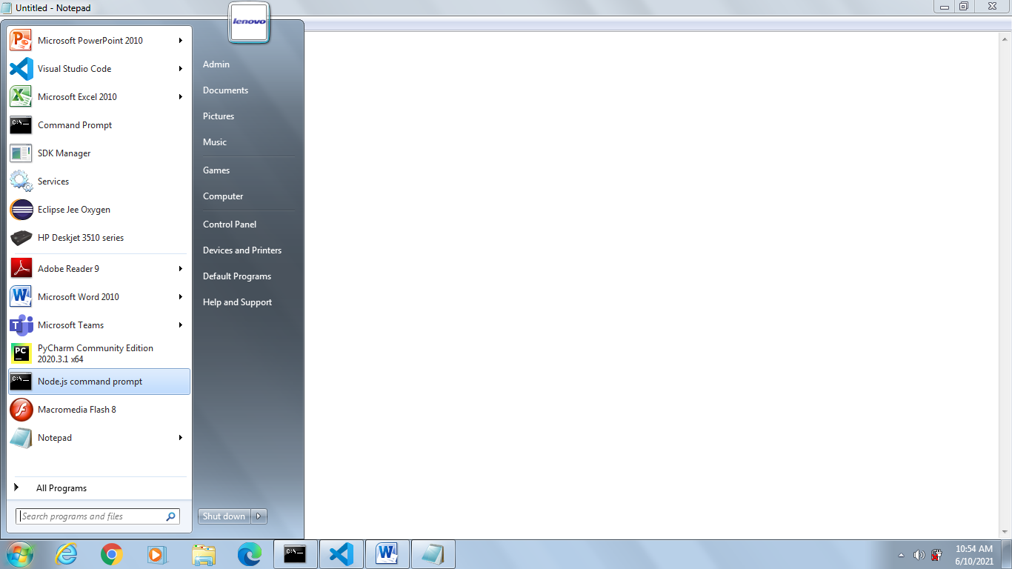

1. **Go to the location where the BMICalculator file is located in command prompt**

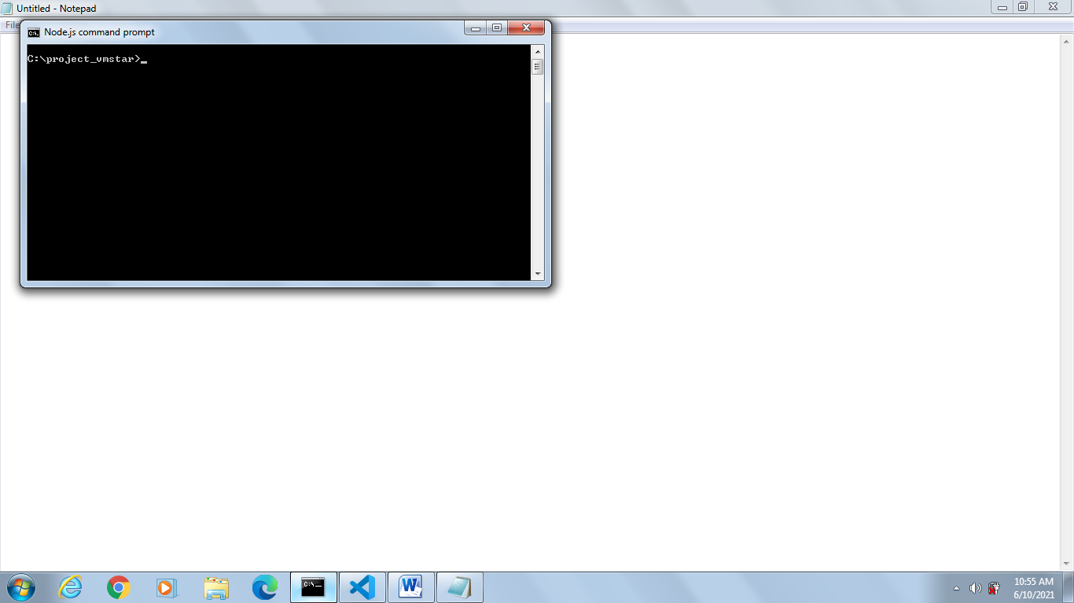

1. **Install the prompt-sync in nodejs if not installed using below command in the command prompt.**

**npm install prompt**

**Note: After the prompt-sync is installed ensure below folders are created in nodemodules folder [node modules folder will be created in the same folder where BMICalculator.js is located]**

1. **Prompt-sync 2. Strip-ansi 3.ansi-regex**

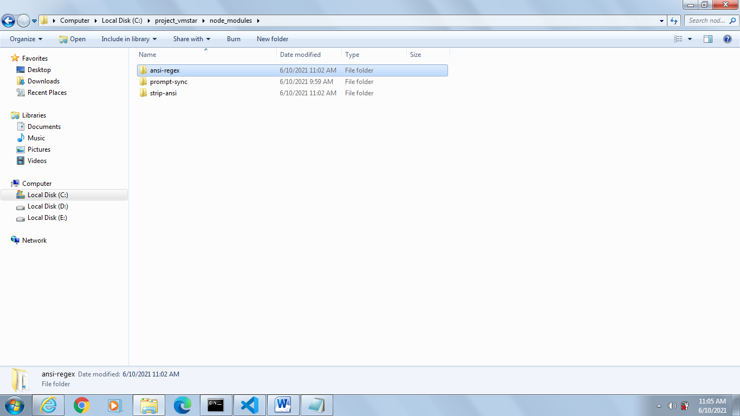

1. **Run the BMICalculator using below command**

**node BMICalculator.js**

1. **Below is the sample output.**

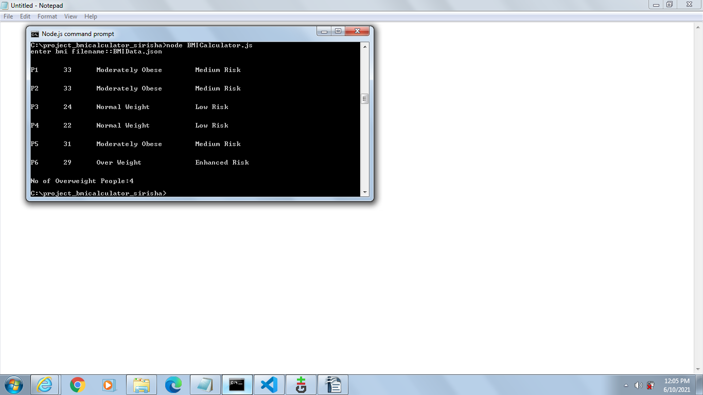

**Sample Input: The input BMI file should be JSON file and in the same directory where the BMICalculator.js is located and in the same below format the JSON data to be.**

[

{"Person":"P1","Gender":"Male","HeightCm":171,"WeightKg":96},

{"Person":"P2","Gender":"Male","HeightCm":161,"WeightKg":85},

{"Person":"P3","Gender":"Male","HeightCm":180,"WeightKg":77},

{"Person":"P4","Gender":"Female","HeightCm":166,"WeightKg":62},

{"Person":"P5","Gender":"Female","HeightCm":150,"WeightKg":70},

{"Person":"P6","Gender":"Female","HeightCm":167,"WeightKg":82}

]